Tarjetas de datos de la estación 2

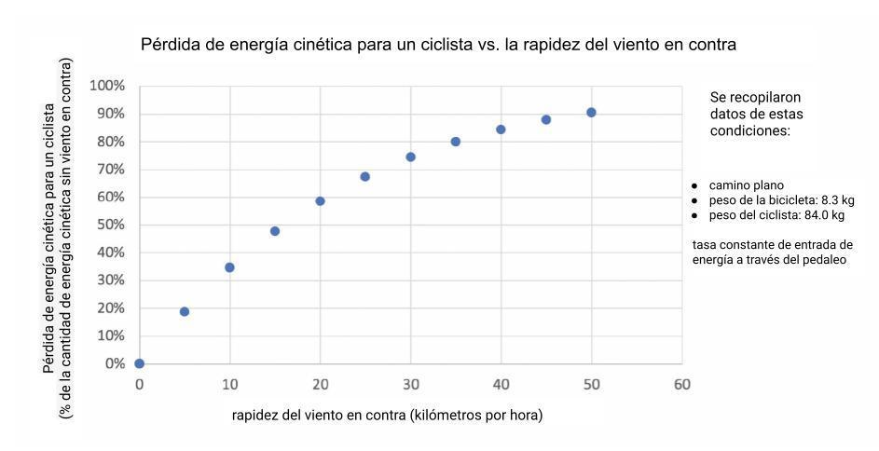
Fuente: Reeve, B. (2020). How much difference does a headwind make when cycling. Obtenido de: https://www.yellowjersey.co.uk/the-draft/how-much-difference-does-a-headwind-make-when-cycling/

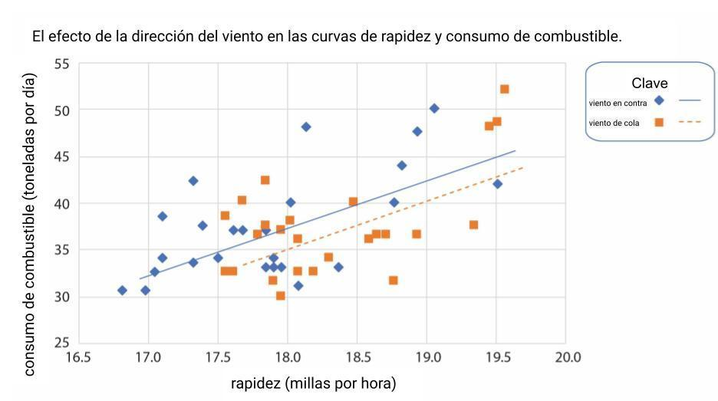
Data adaptada de: Bialystocki, N., & Konovessis, D. (2016). On the estimation of ship's fuel consumption and speed curve: A statistical approach. Journal of Ocean Engineering and Science, 1(2), pp 157-166.

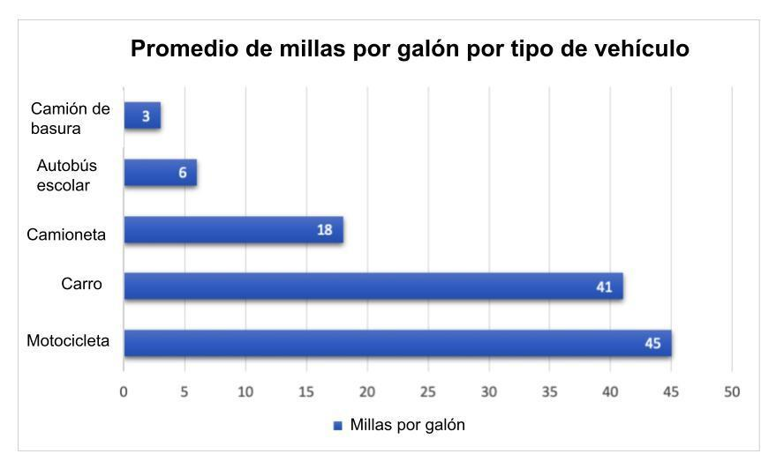
Data adaptada de: Fuente: Federal Highway Administration. Highway Statistics 2016, Table VM-1; Calculated from statistics found in American Public Transit Association's Public Transportation Fact Book 2017; Gordon, D., Burdelski, J., and Cannon, J. S. Greening Garbage Trucks: New Technologies for Cleaner Air. Inform, Inc. 2003; American School Bus Council. National School Bus Fuel Data.

